How to register a sQuid account
Create an account and top up online

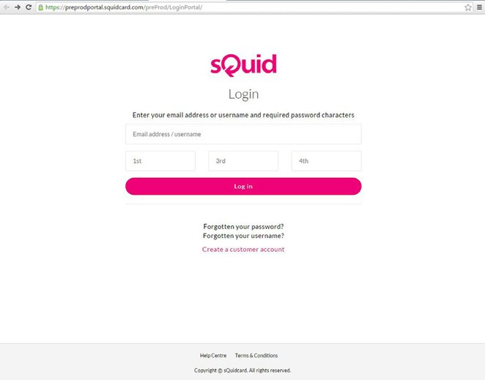
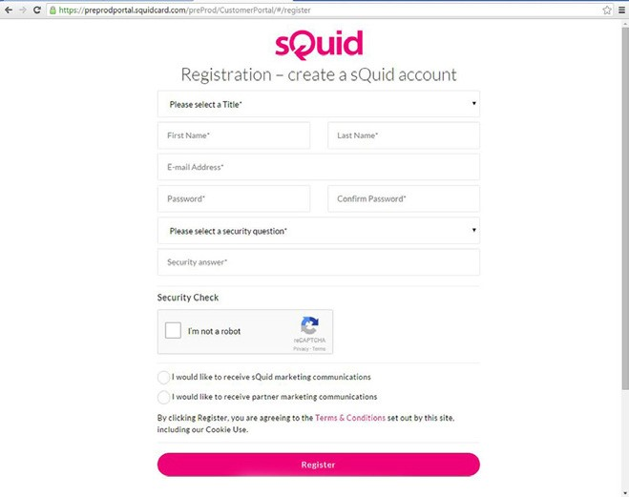
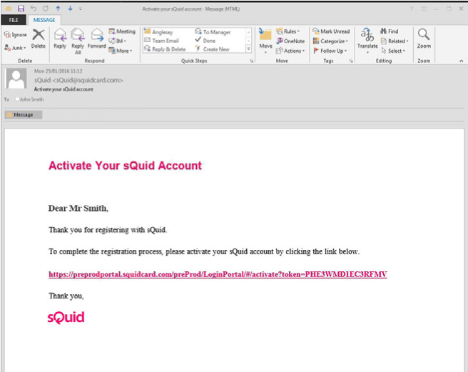
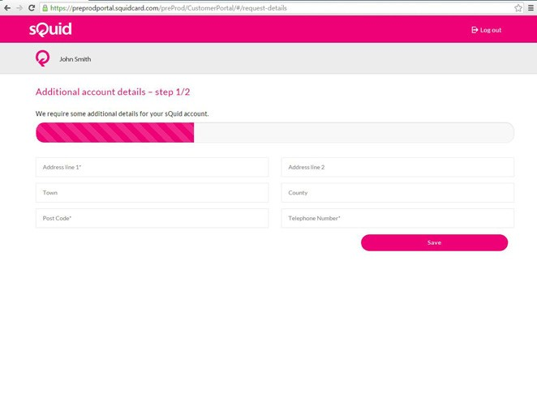
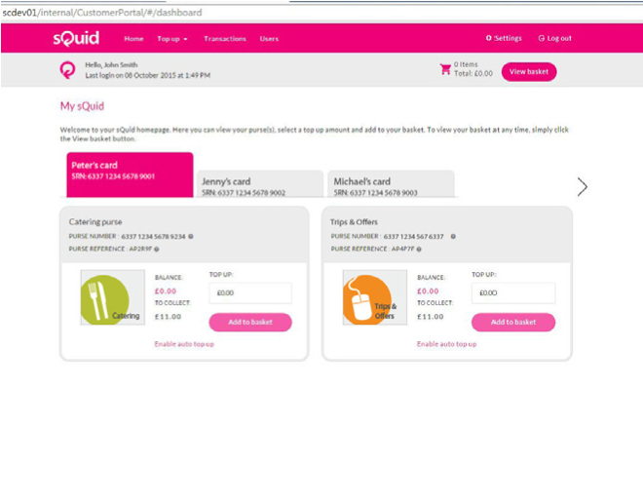
01 Getting started
Go to portal.squidcard.com and click the ‘Create a customer account’ link. You will then be directed through to the sQuid account registration form.

02 Create a sQuid account
You will need to enter your personal details, create a password and select a security question from the list provided, and enter your answer. Click on the ‘Register’ button to complete your registration.

03 Activate your sQuid account
Once your sQuid account is registered, you will receive an email from sQuid containing an activation link. Click on the activation link to be brought back into the sQuid portal, where you will be asked to complete some additional details.

04 Add a sQuid Registration Number (SRN)
Having created your sQuid account, you will be prompted to register your unique sQuid Registation Number. This is the 16 digit number shown on the front of your registration letter, together with your 3 digit security code. Here you can also assign an easy to remember display name.

05 Add funds to your sQuid account
You can add money to your account from a bank transfer or a credit or debit card. Click on the ‘Top up’ link at the top of the page, select your preferred payment method and follow the online instructions.

